Accession QA Dashboard
NOAA-NFMS-OHC-DSCRTP; For Questions Contact: Robert.McGuinn@NOAA.gov; 843-460-9696
Date of report: 2019-03-29

AccessionID: 20190329-0_DatasetID_DWH_NRDA_WS-14-06_DSCRTP_NatDB_20190308-0

DatasetID: DWH_NRDA_WS-14-06
Purpose: Deepwater Horizon Natural Resource Damage Assessment
SurveyComments: NA
- Number of records: 1834
- Number of records flagged: 0
- Minimum depth: 57
- Maximum depth: 89
- Number of dives or tows recorded: 288
- Time frame: 2014 to 2014
- Number of ImageURL populated: 130
- Number of ImageFilePath Populated: 130

Citation
Citation | Records
Etnoyer et al. 2015. Decline in condition of gorgonian octocorals on mesophotic reefs in the northern Gulf of Mexico: before and after the Deepwater Horizon oil spill. Coral Reefs. Volume 35, Issue 1, pp 77-90. | 1834

Web site
WebSite | Records
NA | 1834

Data Origin
DatasetID | DataProvider | Reporter | ReporterEmail | DataContact | Records
DWH_NRDA_WS-14-06 | NOAA, Office of Response and Restoration | Wickes, Leslie | Shuler, Andrew | leslie.wickes@noaa.gov | andrew.shuler@noaa.gov | Etnoyer, Peter: peter.etnoyer@noaa.gov | 1834

Static Map

Locator Map
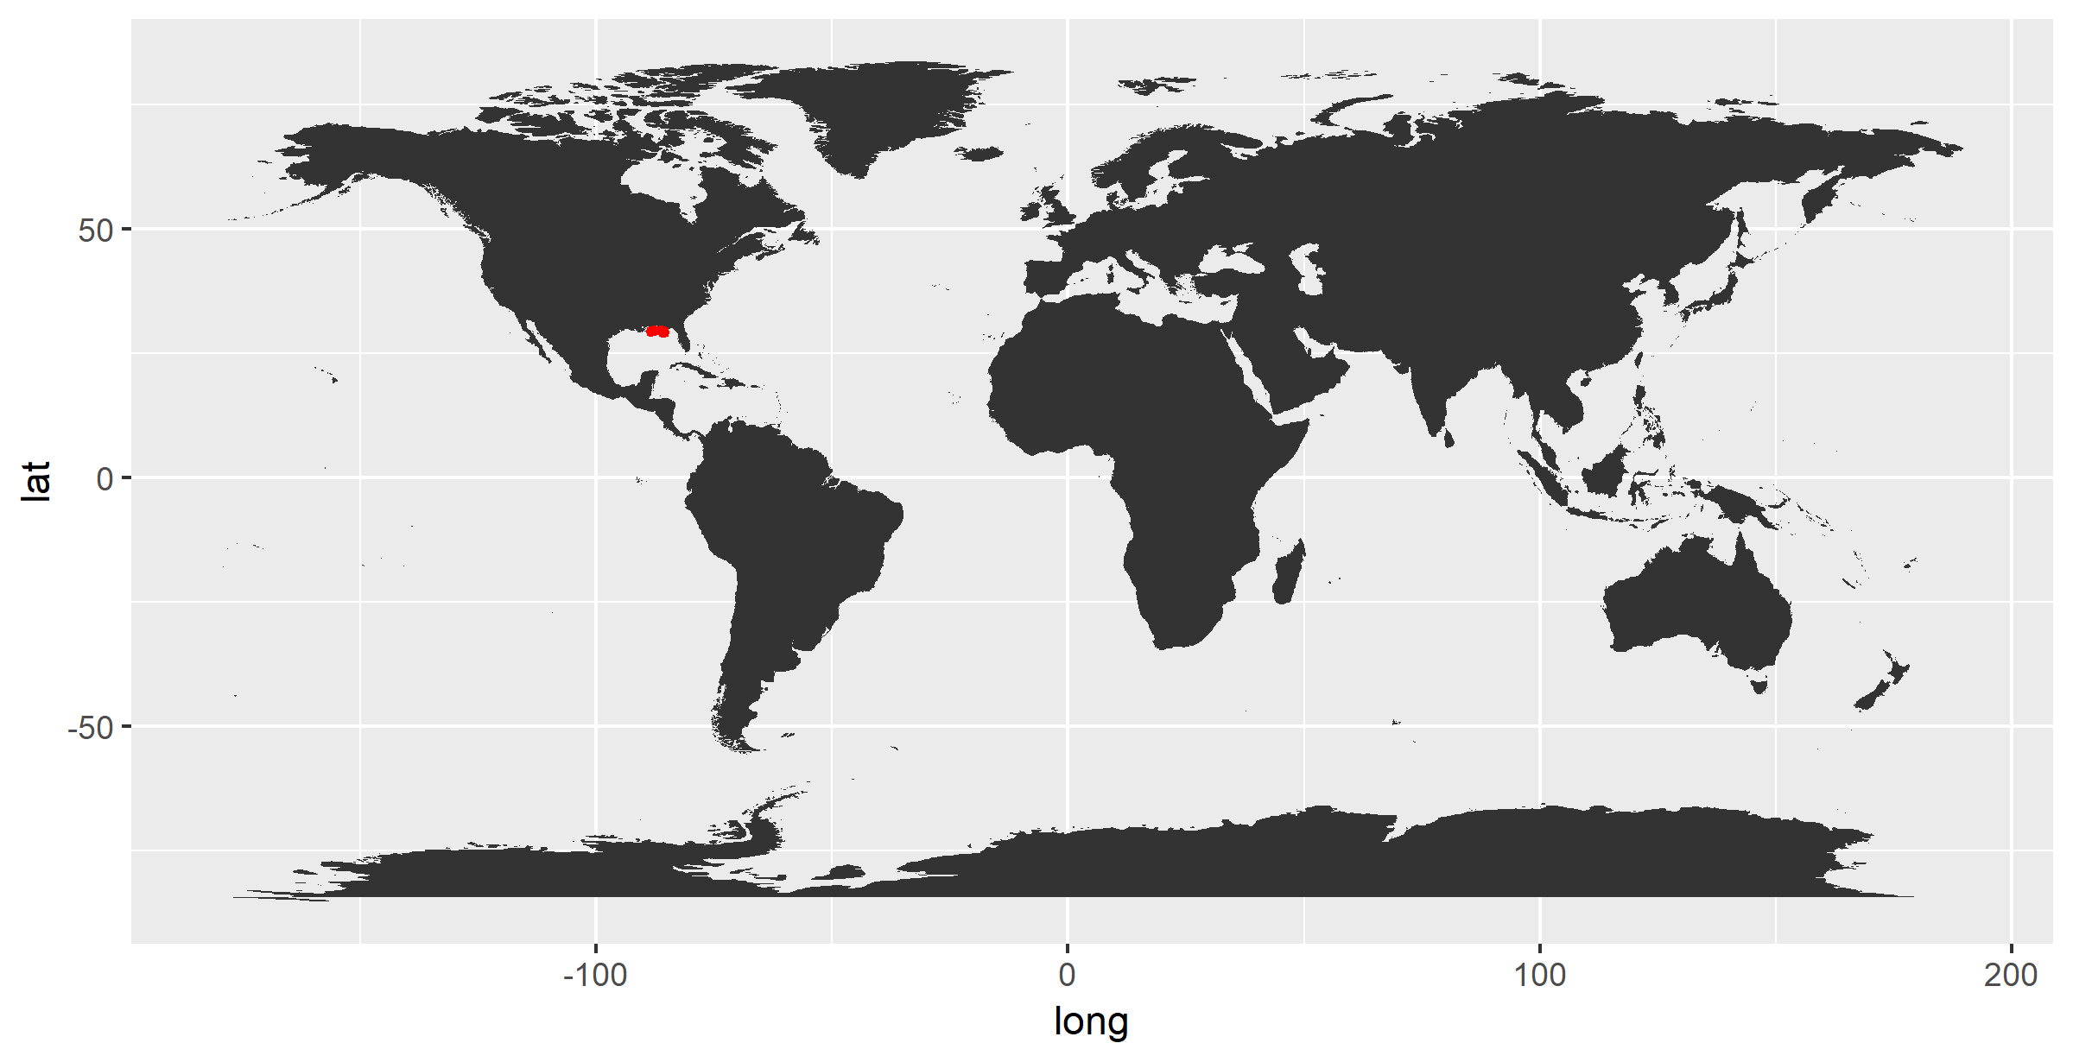

Area of Interest Map
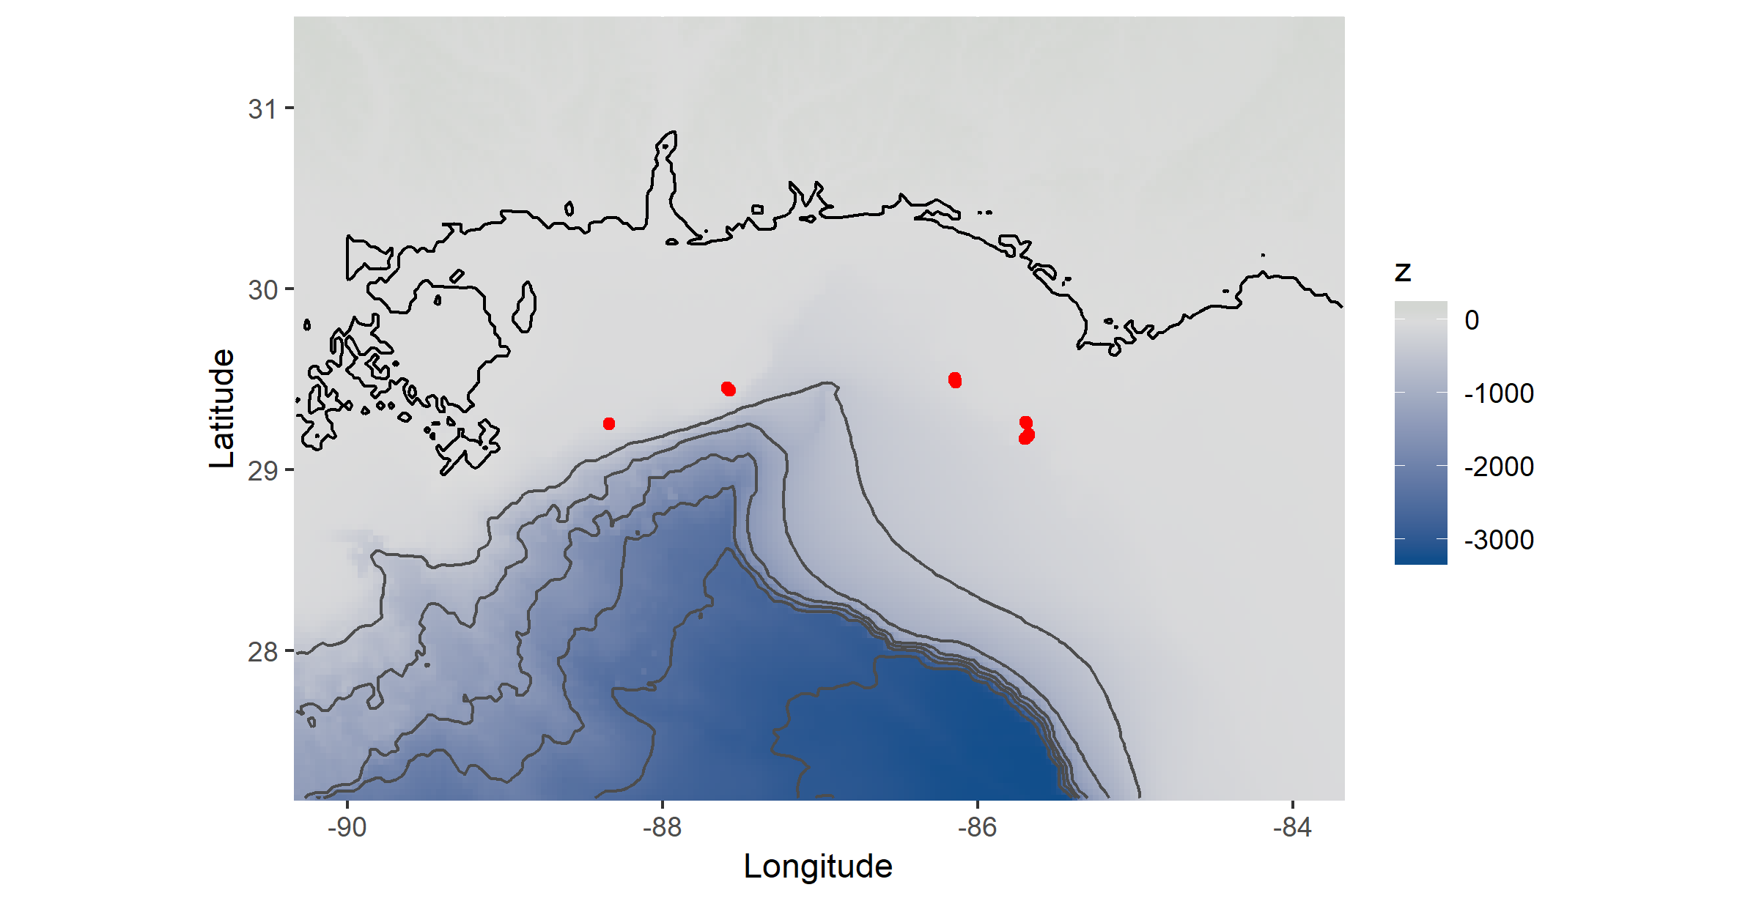

3D Bounding Box
## min max
## Longitude -88.3395 -85.67512
## Latitude 29.1685 29.50620
## DepthInMeters 57.0000 89.00000

Expedition Details
SurveyID | Vessel | VehicleName | SamplingEquipment | NavType | LocationAccuracy | ObservationDates | Records
NRDA Mesophotic 2014 | Walton Smith R/V | Global Explorer MK3 DSR/V | ROV | USBL | 20m | 2014-07-05 | 2014-06-27 | 2014-07-01 | 2014-07-11 | 2014-07-06 | 2014-07-09 | 2014-06-30 | 2014-07-10 | 2014-06-29 | 2014-06-28 | 2014-06-24 | 2014-07-07 | 2014-06-26 | 2014-07-08 | 2014-07-04 | 2014-06-25 | 1834

Taxonomy Details
IdentifiedBy | RecordType | IdentificationQualifier | Records
Wickes, Leslie | Dubick, JD | Frometa, Janessy | video observation | ID by expert from video | 1704
Shuler, Andrew | specimen | morphological ID from sample by taxonomic expert | 130

List of ScientificNames (Coral) - Grouped by Family
Family | ScientificName | TaxonRank | UnFlagged | Flagged | FlagReason | Records
Antipathidae | Antipathes atlantica | Antipathes furcata | Stichopathes sp. | species | genus | 79 | 0 | NA | 79
Ellisellidae | Ellisella sp. | Nicella cf. americana | Nicella sp. | genus | 53 | 0 | NA | 53
Gorgoniidae | Leptogorgia sp. | genus | 15 | 0 | NA | 15
Myriopathidae | Tanacetipathes sp. | genus | 15 | 0 | NA | 15
Plexauridae | Bebryce cf. grandis | Bebryce cf. parastellata | Bebryce cf. cinerea | Bebryce sp. | Hypnogorgia pendula | Muriceides cf. hirta | Paramuricea sp. | Placogorgia rudis | Placogorgia sp. | Placogorgia tenuis | Plexauridae | Scleracis sp. | Swiftia exserta | Thesea cf. guadalupensis | Thesea cf. parviflora | Thesea nivea | Thesea parviflora | Thesea rubra | Villogorgia nigrescens | Villogorgia sp. | genus | species | family | 1672 | 0 | NA | 1672

List of ScientificNames (Sponges) - Grouped by Family
Family ScientificName TaxonRank UnFlagged Flagged FlagReason Records ——- ————— ———- ———- ——– ———– ——–

Location

Localities and EventIDs (Dives/Tows/Hauls)
Locality | EventID | n
Alabama Alps Reef | 2014_WS5_Dive04 | 2014_WS5_Dive05 | 2014_WS5_Dive12 | 2014_WS5_Dive13 | GX001-001 | GX002-002 | GX002-003 | GX002-004 | GX002-005 | GX002-006 | GX002-007 | GX002-008 | GX002-009 | GX005-010 | GX011-071 | GX011-072 | GX011-073 | GX011-074 | GX011-075 | GX011-076 | GX011-078 | GX012-079 | GX012-080 | GX012-081 | GX012-082 | GX012-083 | GX012-084 | GX012-085 | GX012-086 | GX012-087 | GX012-088 | GX012-089 | GX012-090 | GX012-091 | GX013-092 | GX013-093 | GX013-094 | GX013-095 | GX013-096 | GX013-097 | GX013-098 | GX013-099 | GX013-100 | GX013-101 | GX013-102 | GX013-103 | GX013-104 | GX013-105 | 608
Madison Swanson South Reef | GX020-213 | GX020-214 | GX020-215 | GX020-216 | GX020-217 | GX020-218 | GX020-219 | GX020-220 | GX020-221 | GX020-222 | GX020-223 | GX020-224 | GX020-225 | GX020-226 | GX020-227 | GX020-228 | GX020-229 | GX020-230 | GX020-231 | GX020-232 | GX020-233 | GX020-234 | GX020-235 | GX020-236 | GX020-237 | GX020-238 | GX020-239 | GX020-240 | GX020-241 | GX020-242 | GX020-243 | GX020-244 | GX020-245 | GX020-246 | GX020-247 | GX020-248 | GX020-249 | GX021-250 | GX021-251 | GX021-252 | GX021-253 | GX021-254 | GX021-255 | GX021-256 | GX021-258 | GX021-259 | GX021-260 | GX021-261 | GX021-262 | GX021-263 | GX021-264 | GX021-265 | GX021-266 | GX021-267 | GX021-268 | GX021-269 | GX021-270 | GX021-271 | GX021-272 | GX021-273 | GX021-274 | GX021-275 | GX021-276 | 386
Coral Trees Reef | 2014_WS5_Dive17 | 2014_WS5_Dive18 | GX017-145 | GX017-147 | GX017-148 | GX017-149 | GX017-150 | GX017-152 | GX017-153 | GX017-154 | GX017-155 | GX017-156 | GX017-157 | GX017-158 | GX017-159 | GX017-160 | GX017-161 | GX017-162 | GX017-163 | GX017-164 | GX017-165 | GX017-166 | GX017-167 | GX017-168 | GX017-170 | GX017-171 | GX018-172 | GX018-173 | GX018-174 | GX018-175 | GX018-176 | GX018-177 | GX018-178 | GX018-179 | GX018-180 | GX018-181 | GX018-182 | GX018-183 | GX018-184 | GX018-185 | GX018-186 | GX018-187 | GX018-188 | GX018-189 | GX018-190 | GX018-191 | GX019-192 | GX019-193 | GX019-194 | GX019-195 | GX019-196 | GX019-197 | GX019-198 | GX019-199 | GX019-200 | GX019-202 | GX019-203 | GX019-204 | GX019-205 | GX019-206 | GX019-207 | GX019-208 | GX019-209 | GX019-210 | GX019-211 | GX019-212 | 317
Roughtongue Reef | 2014_WS5_Dive07 | 2014_WS5_Dive08 | 2014_WS5_Dive10 | GX007-011 | GX007-012 | GX007-013 | GX007-014 | GX007-017 | GX007-018 | GX007-020 | GX007-021 | GX007-022 | GX007-023 | GX007-024 | GX007-025 | GX007-027 | GX008-029 | GX008-030 | GX008-031 | GX008-033 | GX008-034 | GX008-035 | GX008-036 | GX008-038 | GX008-039 | GX008-041 | GX008-042 | GX008-043 | GX008-044 | GX008-045 | GX008-047 | GX008-048 | GX008-049 | GX009-053 | GX009-054 | GX010-055 | GX010-056 | GX010-058 | GX010-059 | GX010-060 | GX010-061 | GX010-063 | GX010-064 | GX010-065 | GX010-068 | GX010-069 | GX010-070 | 230
Yellowtail Reef | 2014_WS5_Dive16 | GX015-107 | GX015-108 | GX015-109 | GX015-110 | GX015-111 | GX015-112 | GX015-113 | GX015-114 | GX015-115 | GX015-116 | GX015-118 | GX015-119 | GX015-120 | GX015-121 | GX015-122 | GX015-123 | GX015-124 | GX016-126 | GX016-127 | GX016-128 | GX016-129 | GX016-130 | GX016-131 | GX016-132 | GX016-133 | GX016-134 | GX016-135 | GX016-136 | GX016-137 | GX016-138 | GX016-139 | GX016-141 | GX016-142 | GX016-143 | GX016-144 | 170
Madison Swanson North Reef | GX022-277 | GX022-278 | GX022-279 | GX022-280 | GX022-281 | GX022-282 | GX022-283 | GX022-284 | GX022-286 | GX022-287 | GX022-288 | GX022-289 | GX022-290 | GX022-291 | GX022-292 | GX022-293 | GX022-295 | GX022-296 | GX022-297 | GX022-298 | GX022-299 | GX022-300 | GX022-301 | GX022-302 | GX022-303 | GX022-304 | 102
Madison Swanson South Reef South Reef | 2014_WS5_Dive20 | 2014_WS5_Dive22 | 21

NavType
NavType | n
USBL | 1834

LocationAccuracy
LocationAccuracy | n
20m | 1834

Oceans
Ocean | n
North Atlantic | 1834

Countries
Country | n
USA | 1834

FishCouncilRegion(s)
FishCouncilRegion | n
Gulf of Mexico | 1834

Marine Eco-Regions of the World
gisMEOW | n
Northern Gulf of Mexico | 1834

Large Marine Ecosystem
gisLME | n
Gulf of Mexico | 1834

Size, Abundance, and Condition

Individual Count Summary
Nothing will appear here if no ‘IndividualCount’ values are present
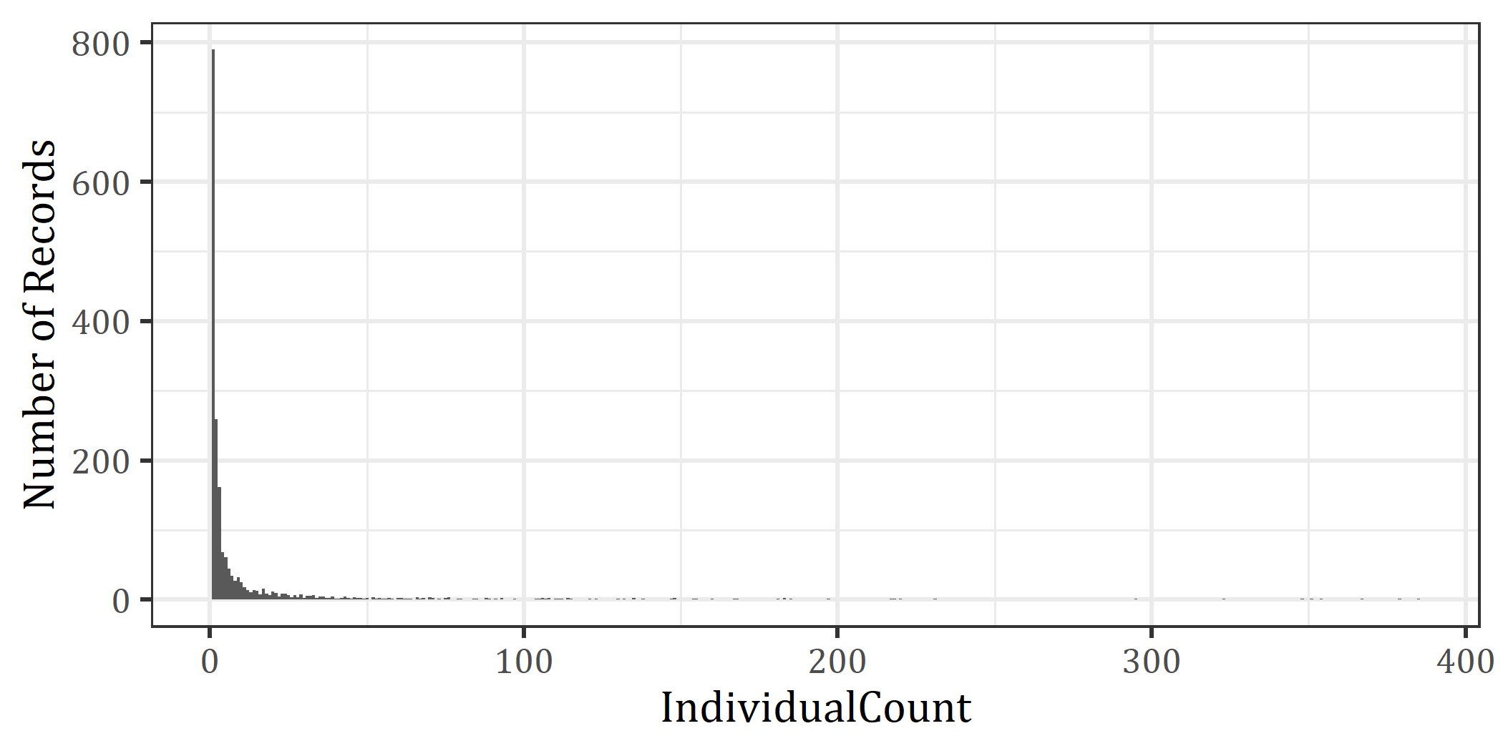

IndividualCount
- min: 1
- median: 2
- max: 385

Categorical Abundance Values
Nothing will appear here if no ‘CategoricalAbundance’ values are present
CategoricalAbundance | n
present | 1834

Cover Values (%)
Arranged in descending order of median ‘Cover’ values. Nothing will appear here if no ‘Cover’ values are present
ScientificName minCover maxCover medianCover n ————— ——— ——— ———— —

Minimum and Maximum Size Values by Genus
This table will be empty if no size values present.
Genus | VerbatimSize_values | min.Size | max.Size | n
Thesea | 10-30 cm, 30-50 cm, <10 cm, 50-100 cm | 0 | 100 | 36
Swiftia | 10-30 cm, 50-100 cm, >100 cm, 30-50 cm, <10 cm | 0 | 100 | 145
Hypnogorgia | 10-30 cm, 30-50 cm, 50-100 cm, >100 cm, <10 cm | 0 | 100 | 60
NA | 50-100 cm, 10-30 cm, 30-50 cm, >100 cm | 10 | 100 | 14

Weight Values
WeightInKg n ———– —

Condition Values
Condition | n
Live | 625
Damaged | 18
51-90% damaged | 84
11-50% damaged | 150
1-10% damaged | 123
>90% damaged | 108
NA | 726

Environment

Habitat and Substrate
Habitat | Substrate | n
NA | NA | 1834

Temperature, Salinity, Oxygen
Histogram of Temperature Values (Celcius) (empty if no Temperature values)
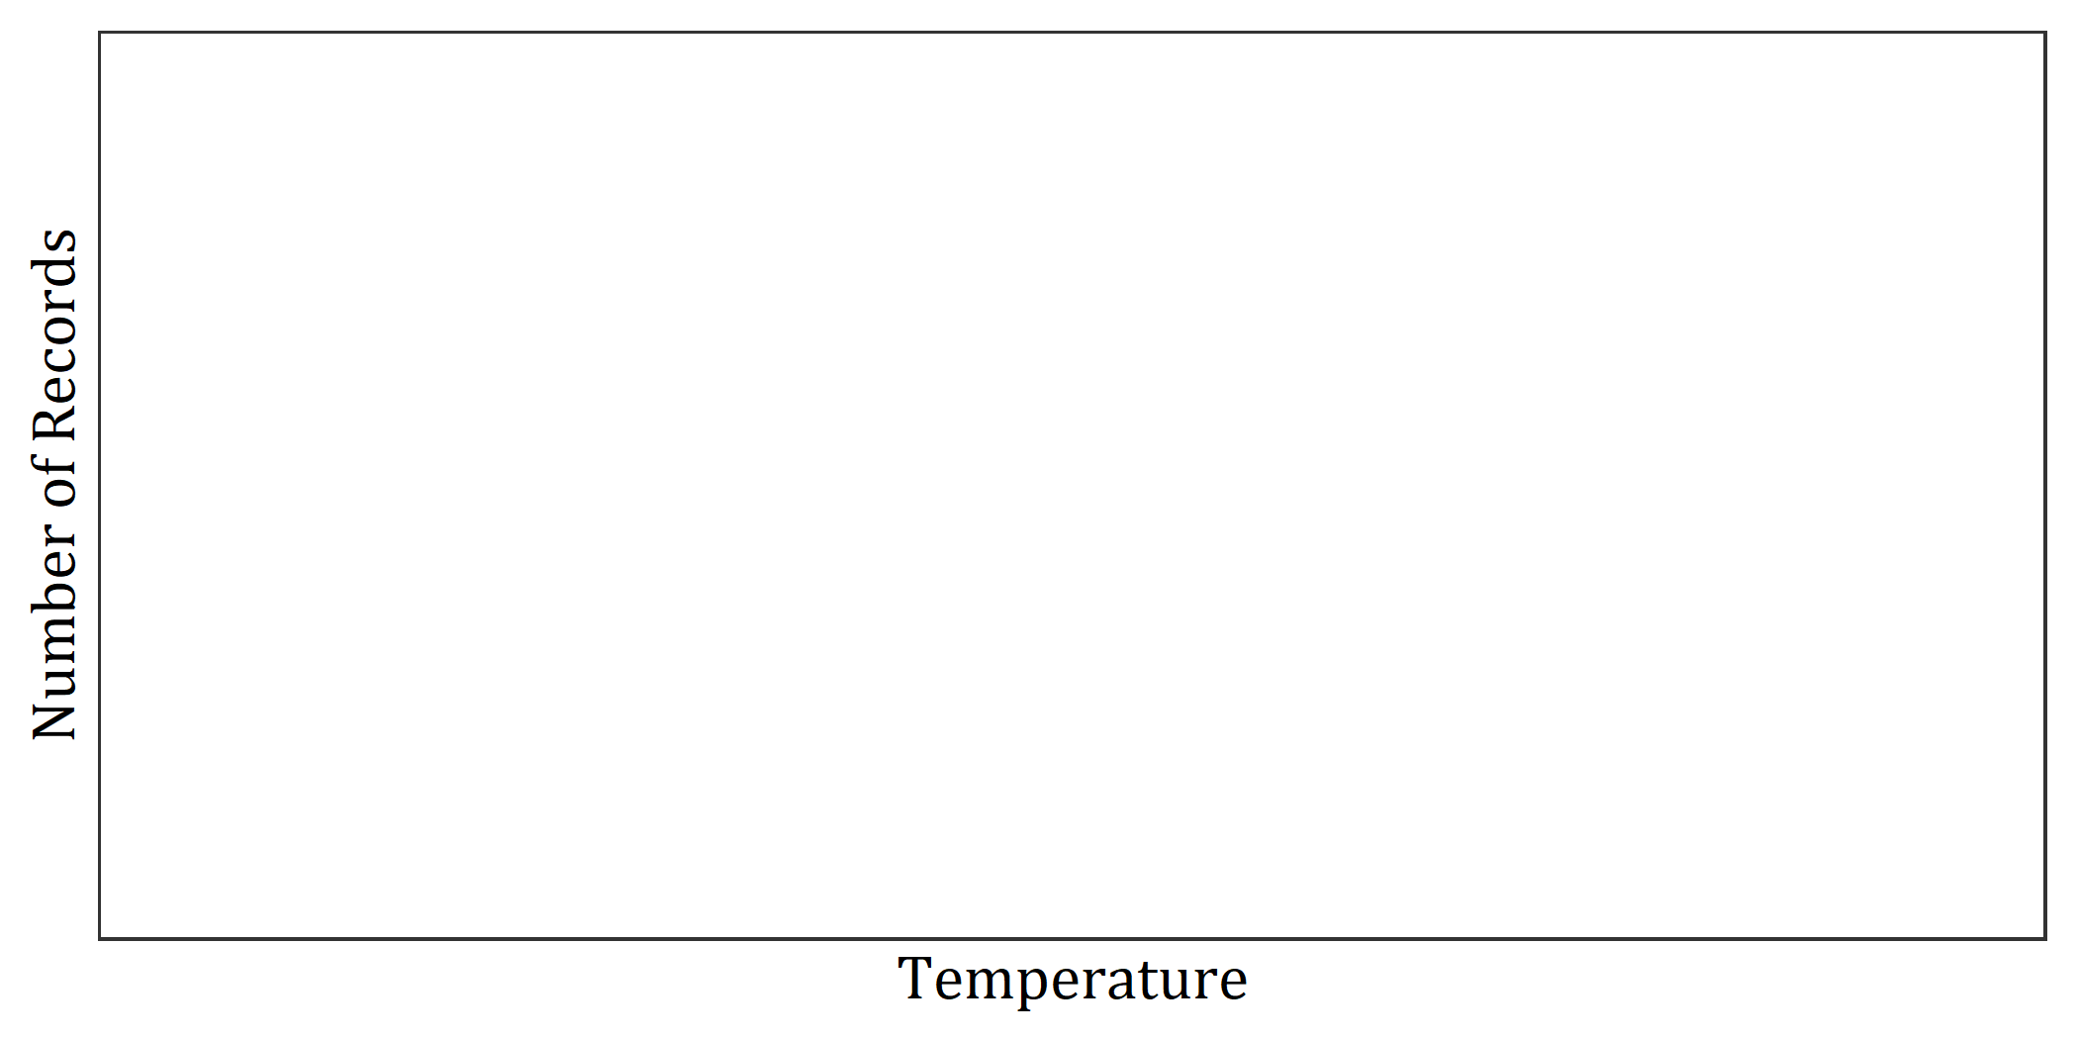
Histogram of Salinity Values (PSU) (empty if no Salinity values)
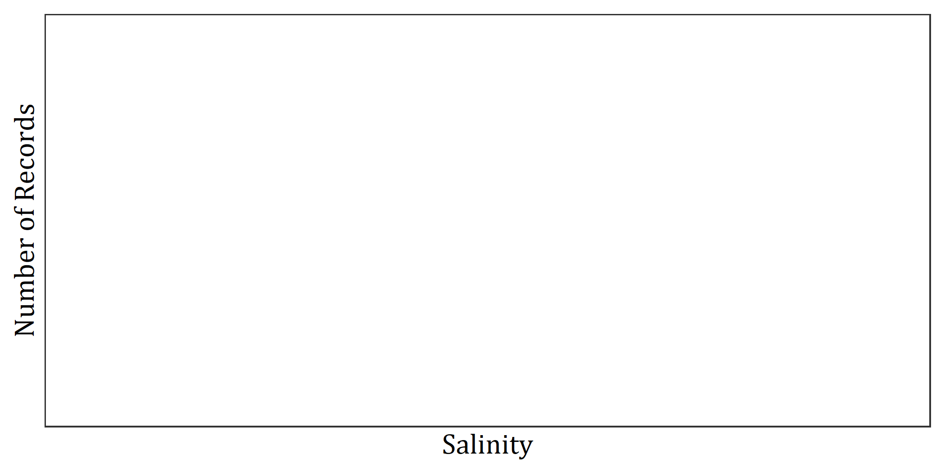
Histogram of Oxygen Values (ml/L) (empty if no Oxygen values)
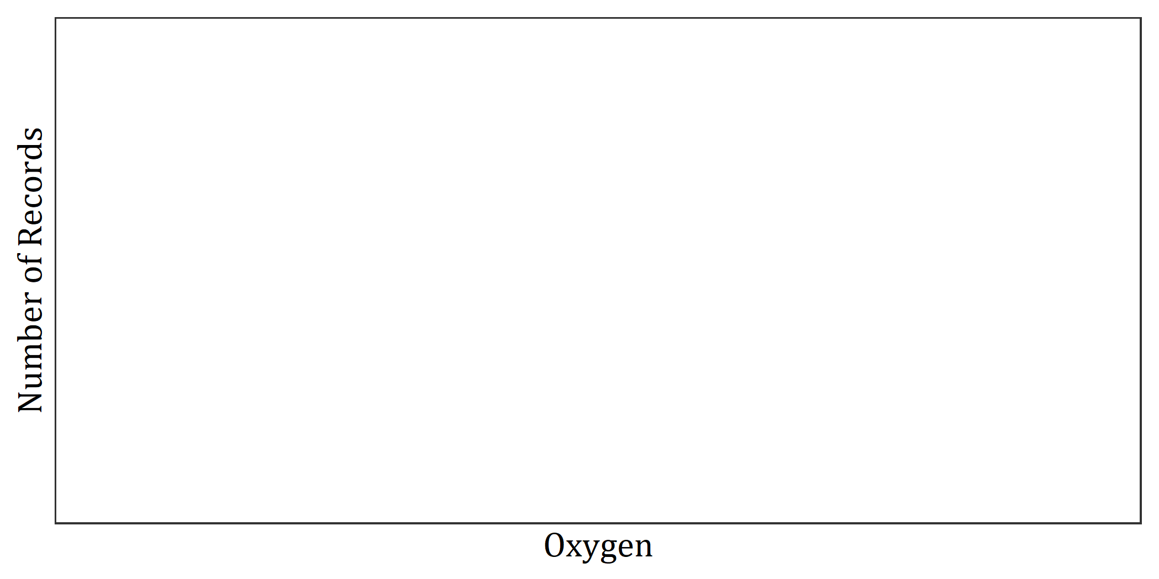

pH Values
pH | n
-999 | 1834

pHscale Values
pHscale | n
NA | 1834

pCO2 Values
pCO2 | n
-999 | 1834

TA Values
TA | n
-999 | 1834

DIC Values
DIC | n
-999 | 1834

Temporal

Observation Time Frame
2014 to 2014

Observation Dates
Number of ObservationDate values recorded:
1834
View of some of the ObservationDate values:
ObservationDate | n
2014-06-24 | 94
2014-06-25 | 10
2014-06-26 | 13
2014-06-27 | 58
2014-06-28 | 125
2014-06-29 | 47
2014-06-30 | 262
2014-07-01 | 229
2014-07-04 | 59
2014-07-05 | 111

Observation Time
Number of ObservationTime values recorded:
1834
View of some of the ObservationTime values:
ObservationTime | n
08:25:49 | 4
08:30:30 | 11
08:34:10 | 5
08:35:22 | 7
08:35:46 | 29
08:36:53 | 2
08:40:27 | 2
08:41:06 | 10
08:41:20 | 4
08:44:59 | 2

Modified Dates
Modified | n
2016-02-23 | 1834

Entry Dates
EntryDate | n
2016-08-30 | 1834

Entry Update
EntryUpdate | n
2018-12-11 | 1834

Flagged Records
FlagReason taxa n ———– —– —

Depth

Histogram of Depth Distribution
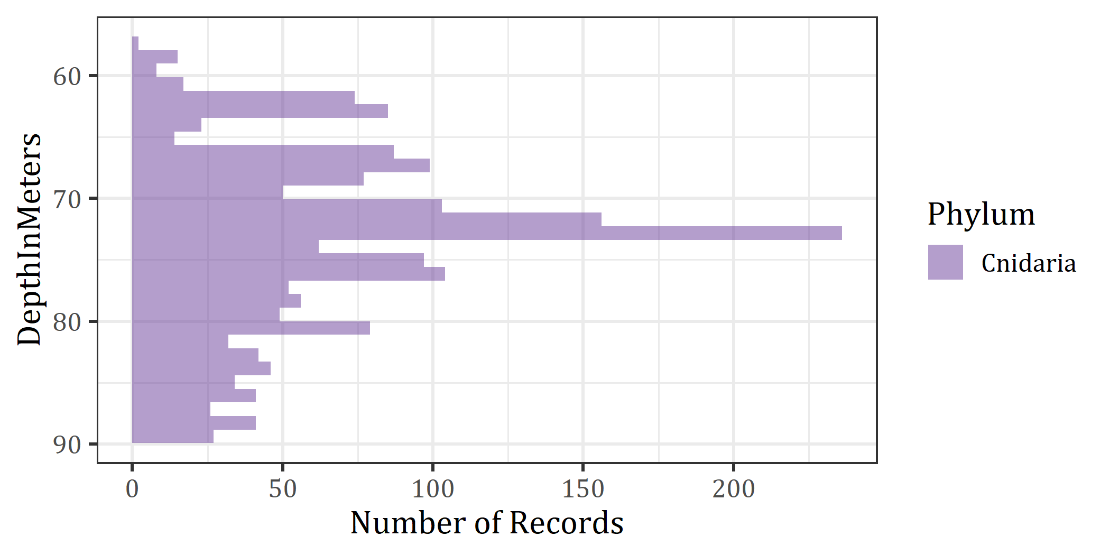

DepthCheck

Depth Summary by ScientificName (Corals)
Table is sorted in alpabetical order.
ScientificName | min.Depth | median.Depth | max.Depth | n
Antipathes atlantica | 62 | 74 | 84 | 26
Antipathes furcata | 62 | 73 | 84 | 28
Bebryce cf. grandis | 58 | 59 | 61 | 6
Bebryce cf. parastellata | 58 | 58 | 58 | 2
Bebryce cf. cinerea | 59 | 62 | 81 | 8
Bebryce sp. | 62 | 68 | 80 | 24
Ellisella sp. | 62 | 68 | 80 | 25
Hypnogorgia pendula | 62 | 73 | 89 | 368
Leptogorgia sp. | 57 | 61 | 73 | 15
Muriceides cf. hirta | 67 | 67 | 67 | 2
Nicella cf. americana | 62 | 62 | 62 | 2
Nicella sp. | 60 | 66 | 80 | 26
Paramuricea sp. | 64 | 67 | 69 | 11
Placogorgia rudis | 64 | 68 | 70 | 24
Placogorgia sp. | 62 | 68 | 80 | 8
Placogorgia tenuis | 79 | 79 | 79 | 2
Plexauridae | 65 | 78 | 89 | 414
Scleracis sp. | 59 | 61 | 68 | 12
Stichopathes sp. | 62 | 68 | 81 | 25
Swiftia exserta | 62 | 69 | 88 | 373
Tanacetipathes sp. | 67 | 76 | 84 | 15
Thesea cf. guadalupensis | 80 | 80 | 80 | 2
Thesea cf. parviflora | 62 | 62 | 62 | 2
Thesea nivea | 62 | 72 | 88 | 221
Thesea parviflora | 62 | 70 | 84 | 8
Thesea rubra | 64 | 83 | 89 | 147
Villogorgia nigrescens | 58 | 61 | 80 | 10
Villogorgia sp. | 58 | 67 | 82 | 28

Depth Summary by ScientificName (Sponges)
Table is sorted in alpabetical order.
ScientificName min.Depth median.Depth max.Depth n ————— ———- ————- ———- —

Points > 30 percent different than Coastal Relief Model
Figure will not show points if none meet the criteria.
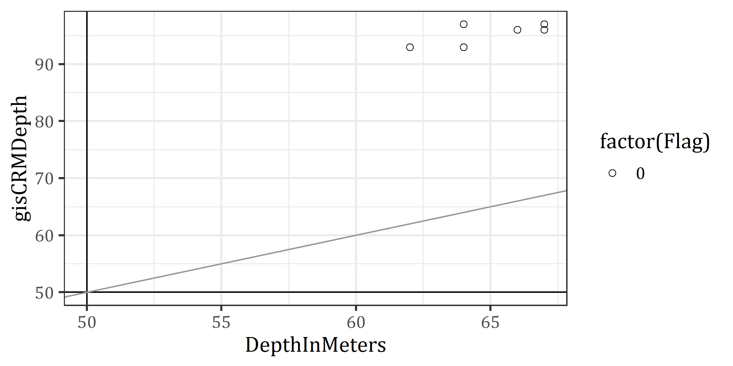

Table of Points > 30 percent different than Coastal Relief Model
Nothing will show here if criteria is not met
CatalogNumber | Scientific_Name | Depth | Etopo | GEBCO | CRM | Flagged
587219 | Muriceides cf. hirta | 67 | 96 | 94 | 96 | 0
587220 | Muriceides cf. hirta | 67 | 96 | 94 | 96 | 0
587241 | Paramuricea sp. | 66 | 96 | 94 | 96 | 0
587242 | Paramuricea sp. | 66 | 96 | 94 | 96 | 0
587252 | Placogorgia rudis | 64 | 96 | 94 | 97 | 0
587253 | Placogorgia rudis | 64 | 96 | 94 | 97 | 0
587254 | Placogorgia rudis | 67 | 96 | 94 | 97 | 0
587255 | Placogorgia rudis | 67 | 96 | 94 | 97 | 0
587258 | Placogorgia rudis | 67 | 96 | 94 | 96 | 0
587265 | Placogorgia rudis | 67 | 96 | 94 | 96 | 0
587266 | Placogorgia rudis | 67 | 96 | 94 | 96 | 0
587283 | Placogorgia sp. | 66 | 96 | 94 | 96 | 0
587284 | Placogorgia sp. | 66 | 96 | 94 | 96 | 0
587309 | Stichopathes sp. | 66 | 96 | 94 | 96 | 0
587310 | Stichopathes sp. | 66 | 96 | 94 | 96 | 0
587327 | Swiftia exserta | 66 | 96 | 94 | 96 | 0
587328 | Swiftia exserta | 66 | 96 | 94 | 96 | 0
587335 | Thesea cf. parviflora | 62 | 89 | 85 | 93 | 0
587336 | Thesea cf. parviflora | 62 | 89 | 85 | 93 | 0
587345 | Thesea nivea | 64 | 89 | 85 | 93 | 0
587346 | Thesea nivea | 64 | 89 | 85 | 93 | 0
587356 | Thesea rubra | 64 | 89 | 85 | 93 | 0
587357 | Thesea rubra | 64 | 89 | 85 | 93 | 0

Points > 60 percent different than ETOPO1
Figure will not show points if none meet the criteria.
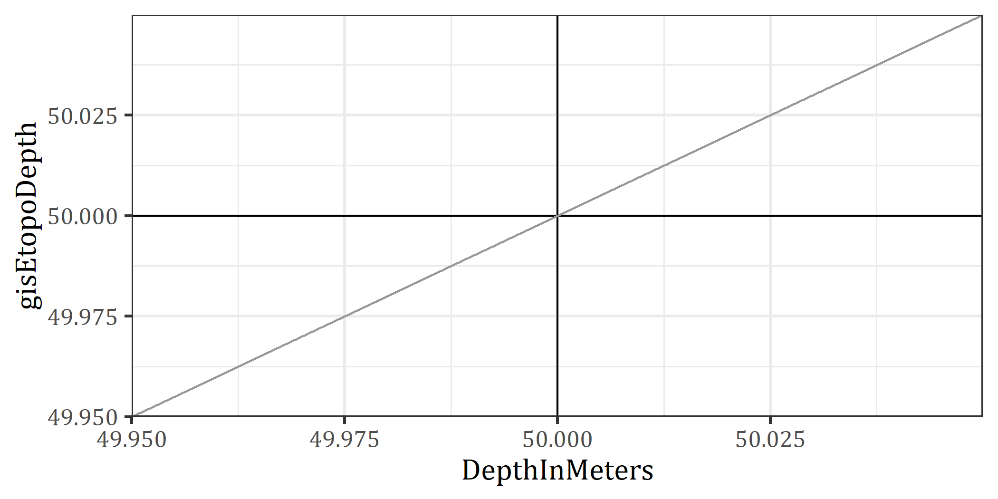

Table of Points > 60 percent different than ETOPO
Nothing will show here if criteria is not met
CatalogNumber Scientific_Name Depth Etopo GEBCO CRM Flagged ————– —————- —— —— —— —- ——–

Points > 60 percent different than GEBCO
Figure will not show points if none meet the criteria.
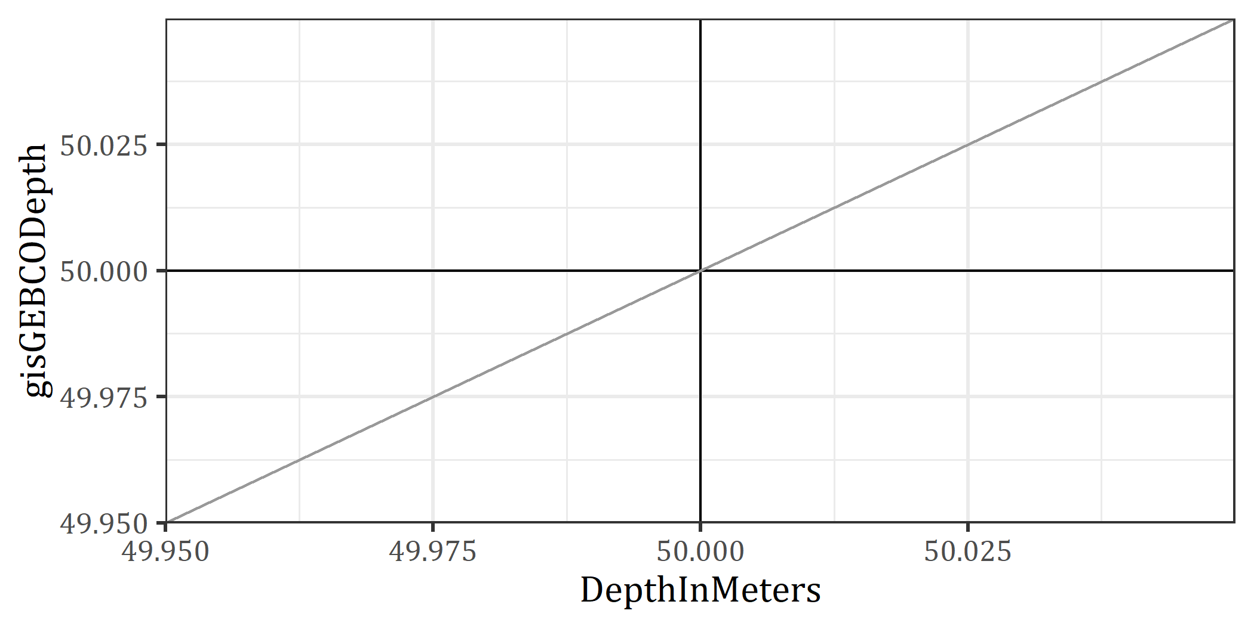

Table of Points > 60 percent different than GEBCO
Nothing will show here if criteria is not met
CatalogNumber Scientific_Name Depth Etopo GEBCO CRM Flagged ————– —————- —— —— —— —- ——–

Points < 30m depth
Figure will not show points if none meet the criteria.
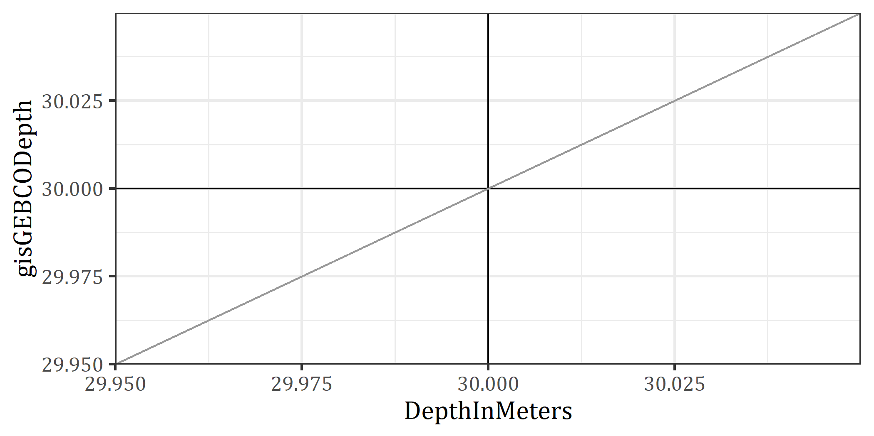

Table of Points < 30m depth
Nothing will show here if criteria is not met
CatalogNumber Scientific_Name Depth Etopo GEBCO CRM ————– —————- —— —— —— —-

